*Follow us on Facebook (Take Stock in Children – Monroe County; @takestockmonroe)
My College Success Coach is ___________________________________________________________
Contact Phone: (______) -____________________________Email: _______________________

1st Quarter (Aug 10 – Oct 7)
- Maintain “Active” status according to the Take Stock requirements for the 1st Quarter.
Circle your current Status. ACTIVE WARNING PROBATION 1 PROBATION 2
- What date did/will you meet with your College Success Coach in Q1? Date:_________________
- Attend FAFSA, Financial Aid workshop. To apply for FAFSA financial aid, for the 2023-2024 year, you can apply between October 1, 2022, and June 30, 2024 www.studentaid.ed.gov/sa/fafsa

- Begin your FAFSA (Free Application for Federal Student Aid). All students need to complete the 2023-2024 FAFSA.
The FAFSA application: for students entering college for the 2023-2024 school year, your parents 2021 income tax records are needed. When attending college, the FAFSA needs to be filed for EACH year attending college.
- Create a GPA goal to reach for each semester and review your 4 year final cumulative GPA.
- 12th Grade GPA Goal Semester 1: _____ 12th Grade GPA Goal Semester 2: _____ 4 Year Cumulative GPA Goal: _____
Remember your community service hours. 100 hours are currently needed for the Bright Futures Academic Scholarship & 75 are needed for the Medallion Scholarship. Service hours earned to date: ___________
- You can review all Bright Futures requirements at http://www.floridastudentfinancialaid.org/ssfad/bf/
- Stay involved in at least one school club this year. What Club? __________________________
- What are your top three choices for college:
1. _________________________ 2. _________________________ 3. ____________________________
- Early Decision deadlines are often October 1st. Complete all Early Decision applications first!
- Explore their application process. Look at their applications, essay/biographical requirements, average GPA, exam requirements, recommendation requirements, etc.
  - Check out the virtual tours at websites of any colleges you are interested in attending.
  - Log-in with them as this will get them to mail or email you additional information.
  - If you feel very strongly about 1 or 2 schools, consider applying for early admission. These deadlines often close on or before November 1st. Check with that particular college for the dates.
  - Be sure to have your scores sent to every school you may want to attend. Your scores will be updated every time you retake an exam, and this will get you on their mailing list
- Create a GPA goal to reach for this year and review your 4-year final cumulative GPA.
12th Grade GPA Goal: __________ 4-year Cumulative GPA Goal: __________
Are you on track with the GPA requirements for your top 3 schools?

- Read your “Post-Graduation Goal Setting” worksheet from your freshman year. Is it still in-line with your plans?
- Register for either the SAT or ACT to retake before December of this year. If you can, retake them BOTH.
sat.collegeboard.com/register/sat-dates www.actstudent.org/regist/dates.html
What dates will you take the test: SAT: ______________ ACT: _________________
Remember: focus on the test in which you already scored better to achieve your admission goals.
- Attend a College Application and Essay Writing Workshop. (This may be one type of several workshops for college
readiness during your Junior/Senior year, named “Writing for Success”, etc.)
Date: _____________ Location: ___________________________________________________
- Use a Scholarship Planner to apply to and keep track of scholarships throughout your senior year.
- Find 2 more scholarships to add to your Scholarship Planner. Find scholarships using your guidance counselor & this website: https://bigfuture.collegeboard.org/pay-for-college/scholarship-search
- Don’t forget about: https://www.act.org/content/act/en/products-and-services/the-act/test-preparation/free-act-test-prep.html & sat.collegeboard.org/practice/ for free practice questions, tips, study guides, and tests for the ACT and SAT.
- Which colleges/universities/technical schools have you applied for?
Schools: __________________________________________________________
- Are you still in the process of completing applications for any college/universities/technical schools?
Schools: __________________________________________________________
- Begin developing outlines and rough drafts for your college and scholarship essays. When first drafts are completed, ask for feedback from your mentor, teachers and others.
- Consider who you will need to ask for recommendations. Colleges may want specific people to do this. Give those people plenty of advance notice and have forms or website information available for him/her when you ask. Be sure to thank him/her later.
- Don’t forget to have senior pictures taken. Even if you choose not to purchase a package, check with your school’s yearbook advisor about having a photo made for the yearbook and for other senior recognition opportunities (such as, Take Stock in Children).
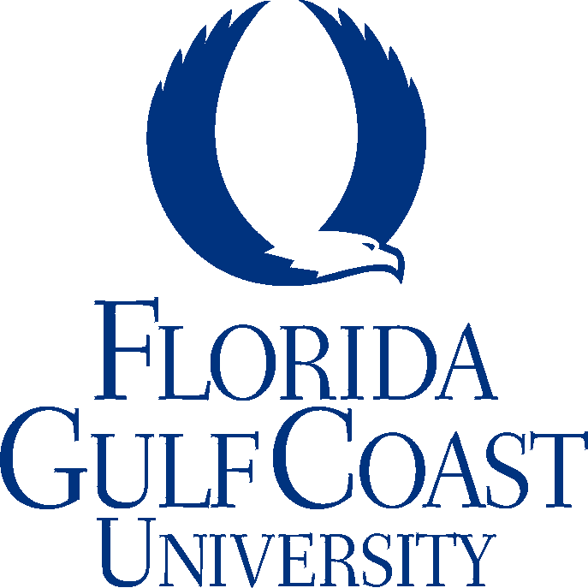

Apply for admission to the colleges you have chosen. Be sure to do the following:
- Complete your essays and attach them to your application. Be sure to keep copies.
- Check the college website for scholarships that apply to incoming freshman. Note the deadline for these scholarships, as they can be early. Apply as directed.
- Check on your recommendation letters. Keep any copies that are given to you, or documentation that indicates they were done on-line.
- Have your transcripts sent to the colleges where you have applied. Your application is not complete until they have received them.
- Wait one or two weeks, and then check with the admissions office where you have applied to confirm that they have received your application and all supporting documentation.
- Check with your guidance counselor to find out when your local scholarships packet will be available.

2nd Quarter (Oct 11 – Dec 16)
- Maintain “Active” status according to the Take Stock requirements for the 2nd Quarter.
Circle your current Status. ACTIVE WARNING PROBATION 1 PROBATION 2
- What date did/will you meet with your College Success Coach in Q2? Date: _____________
- Have ALL of your college applications completed by November!
Remember: Schools can accept you without all requirements being met with a final decision made at the end of year.
- Attend the Mandatory FAFSA & Financial Aid Workshop.
Date: ____________ Location: ______________________________________________
You will complete important paperwork for activating your scholarship at this workshop. DO NOT MISS IT!
- After December 1st: apply for the Florida Bright Futures Scholarship. This application will also apply you to other local scholarships. It is best to complete it before you graduate. The absolute final deadline is August 31st the year you graduate high school.
This Photo by Unknown Author is licensed under CC BY-NC-ND
- Look for a way to volunteer and earn service hours during the winter holiday.
How? ____________________________________________________
- Update your high school resume with awards/achievements, paid or volunteer work, extracurricular activities, classes taken, fluent language(s), and technical skills from 1st semester.

3rd Quarter (Jan 4 – Mar 16)
- Maintain “Active” status according to the Take Stock requirements for the 3rd Quarter.
Circle your current Status. ACTIVE WARNING PROBATION 1 PROBATION 2
- Did you reach your 1st semester GPA goal? _____ Yes _____ No
- What date did/will you meet with your College Success Coach in Q3? Date: _____________
- Gather tax forms and any other necessary documents.
- Complete the FAFSA form as soon after October 1 as possible. Some scholarship money is dependent on FAFSA being completed and is given out on a first-come-first-served basis. Also, be sure to print a copy of everything.
- Check your email daily for financial aid and scholarship deadlines and any additional information that may be required. Colleges often require additional documentation of income called a verification worksheet. Make sure you fill out any forms asked for in a timely manner. If you have any concerns or questions, contact the financial aid office at the college.
- State FAFSA deadlines are usually in May of the summer after high school graduation
- Federal FAFSA deadlines are usually in June of the summer after high school graduation

- If you plan on attending a summer session you must also complete the 2023-2024 FAFSA
- Attend the FAFSA Walkthrough Workshop. (programs should have this workshop prior to October 1, a follow-up for the previous FAFSA-Financial Aid workshop, OPTIONAL for local programs)
Date: _____________ Location: _________________________________________________
- Notify the colleges and universities that have accepted you of your plans.
“Yes, I will attend” or “No I have decided to attend another institution.”
- Check on housing deadlines and apply for your choice of housing. You will need to send a deposit for your housing.
- Spring break is another great opportunity to earn more service hours! Where? _____________________________

4th Quarter (Mar 27 – May 26)
- Maintain “Active” status according to the Take Stock requirements for the 4th Quarter.
Circle your current Status. ACTIVE WARNING PROBATION 1 PROBATION 2
- What date did/will you meet with your College Success Coach in Q4? Date: _______________
- Are you on track to reach your 2nd semester GPA goal? _____ Yes _____ No
- Attend the Take Stock in Children Graduation Ceremony!
Date: ____________ Location: ___________________________________________________
- Complete a “Short Term Study Plan” (local program OPTIONAL)

- Mandatory Senior College Prep Workshop (Usually in 4th QTR)
Date: ___________ Location: _____________________________________________________
*The final documents for your scholarship activation are given at this event. DO NOT MISS IT! (Local program OPTIONAL TO COLLECT THIS INFORMATION AT THIS WORKSHOP
- If you are under the required scores for remedial classes, take the PERT again this summer. Do everything you can to reach college-ready level before classes in August.
- Register online for the Take Stock in Children Alumni Alliance. http://www.takestockinchildren.org/alumni/
- Update your high school resume with awards/achievements, paid or volunteer work, extracurricular activities, classes taken, fluent language(s), and technical skills from your 12th grade school year.
- Don’t forget to sign up for an orientation session at your college. There is a charge for these and some require an overnight stay. The earlier you go to orientation, the better class selection you will have.
- Your College Success Coach will have you fill out an Annual Florida Prepaid Student Information form. This form will need to be updated online each year for your tuition to be paid by Florida Prepaid.
Florida Prepaid tuition account is your Take Stock scholarship!
- No senioritis! Be diligent in keeping up with deadlines for any paperwork the college requires. Keep working hard so that your final transcript will be acceptable to your college.
- Look over the meal plans offered by your college and discuss them with your parents.
- Keep your Florida Prepaid account information in a safe place! You should show it to the cashier when you pay for your tuition. Have your high school send your final transcript to the college you will be attending. If you took Dual Enrollment classes you need to also request a copy of your college transcript sent to the College. The College will expect YOU to be responsible for your finances and education.
- Attend your local program TSIC graduation ceremony!
This Photo by Unknown Author is licensed under CC BY-NC-ND
.
Congratulations!
You’ve made it!

Don’t forget to thank people who helped you along the way!

Be sure to thank everyone who has helped you along the way

